Figures 1 and 2:

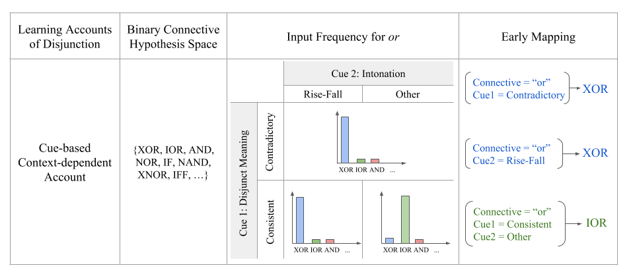Table 2: Cue based, Context Dependent Account Remedies Apparent Contradictions of Usage and Nativist Theories

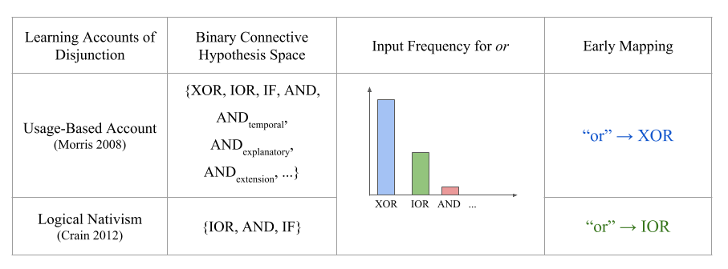

Caption: Summaries of the usage, nativist, and cue-based approaches to disjunction acquisition. For each theory, we present the name, the binary connective hypothesis space considered, the conceptualization of the input frequency for or, and the approximate early mappings constructed by child learners.

Note: Felt Clunky, but could include

Figure 3, Table 2, Figure 4, and Figure 5:

Figure 1: In a natural language corpus, Children Speak Less than Parents, Use a Higher Proportion of Directives, and Develop Questions over time





Caption: (A) Frequency for all the words in the North America and UK corpora of CHILDES (B) Number of and’s, or’s, and the total number of words in the speech of children and their parents in English-North America and English-UK collections after exclusions. (C) The proportion of declaratives and questions in children’s and parents’ utterances. (D) Proportion of declaratives to questions in parent-child interactions by age.

Comments: Figures 4 and 5 provide the same information, just in different ways. I’d recommend just dropping Figure 4 and Just focusing on 5 because it provides more information

Note: Drop all three other than change over time

Figures 7, 8, 9, 10:

Figure 2: Children’s Development of Or Tracks with Development of Questions



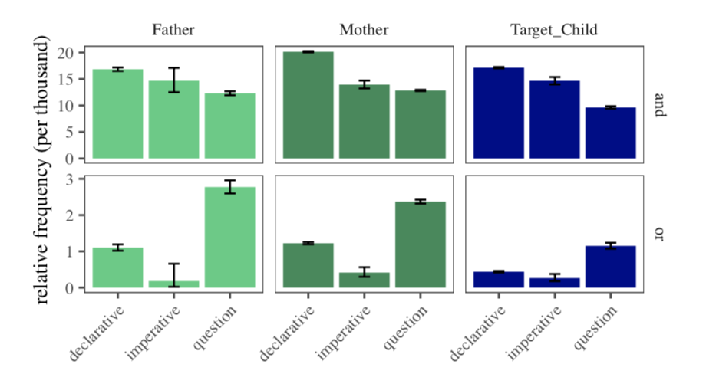

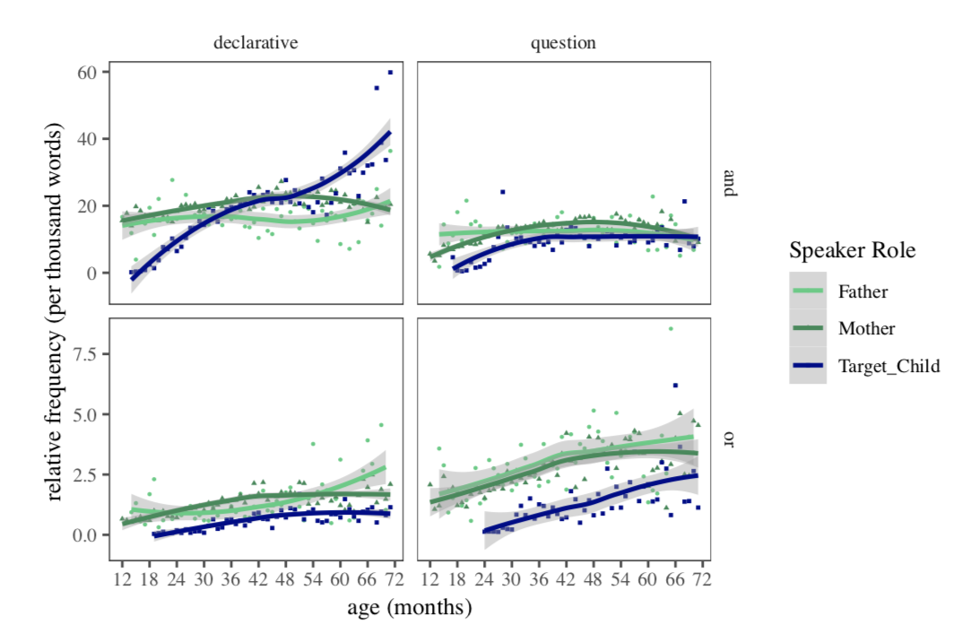

Caption: (A) The relative frequency of *and/or* in the speech of fathers, mothers, and children. 95% binomial proportion confidence intervals calculated using Agresti-Coull’s approximate method. The monthly relative frequency of *and/or* in parents and children’s speech between 12 and 72 months (1-6 years). Relative frequency of *and/or* in declaratives, imperatives, and interrogatives for parents and children. Relative frequency of *and/or* in declaratives and questions for parents and childern between the child-age of 12 and 72 months (1-6 years).

Comments: I’d advocate for cutting Figure 6 entirely. All of the information coming from 6 can be discussed using Figure 9. Additionally, I’m not sure if 7 and 8 are both necessary. Again, 8 covers all the same material as 7 but with more detail, so I’d drop 7

Figures 12, 13, 14, 15, 16, 17, 18:

Figure 3: The proportion of connective interpretations varies by context











Caption: The proportion of connective interpretation broken down by contextual cues. (A) Interpretation by the word used (A), sentence type (B), intonation pattern (C), disjunct consistency (D), disjunct clause type (E), and communicative function (F). (G) Interpretation broken down by two different contextual cues: intonation pattern and consistency.

Comment: We can make many of these figures smaller by creating supplementary figures. Like in my eyes, I see figure 17 and 18 in a supplementary figure

Note: focus on bottom plot, move the rest to a supplementary figure

Figures 20, 21:

Figure 4: Exclusive and Inclusive interpretations are contextually dependent



Caption: (A) Proportion of exclusive and inclusive interpretations of disjunction in child-directed speech. Error bars represent bootstrapped 95% confidence intervals. (B) Exclusive and inclusive interpretations broken down by intonation (flat, rise, rise-fall) and consistency. Error bars represent bootstrapped 95% confidence intervals.

Figures 22, 23, 24, 25:

Figure 5: A Decision Tree Can Distinguish XOR and IOR using intonation and consistency

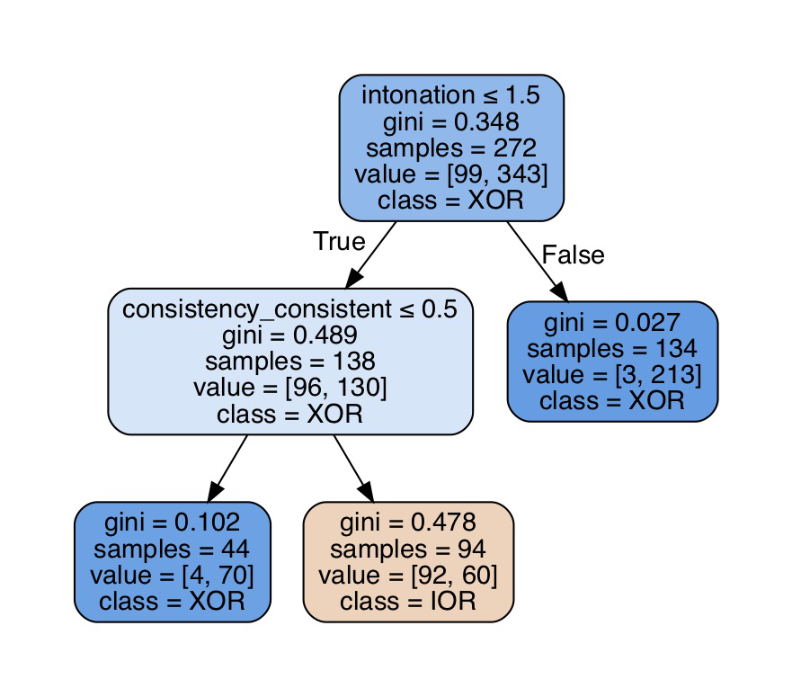

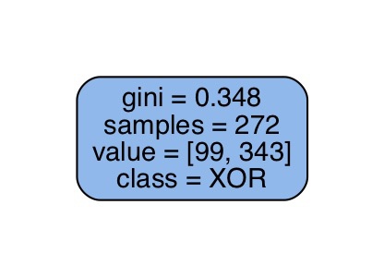

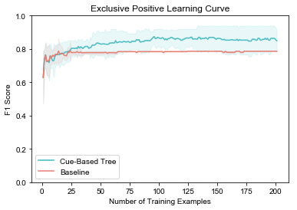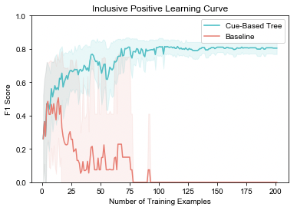

Caption: (A) The structure for the baseline (highest gini threshold, 0.2) decision tree trained on examples with XOR and IOR interprtations. (B) The structure for the tree with gini threshold of 0.01. (C) The average F1 score for XOR with 95% confidence intervals as a function of the number of training examples in the baseline and cue-based model. (D) The average F1 score for IOR with 95% confidence intervals for the baseline and cuebased models

Figures 28, 30, 31:

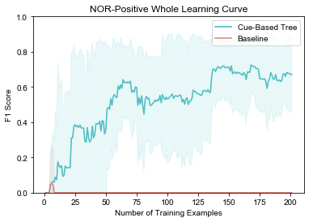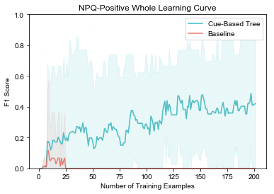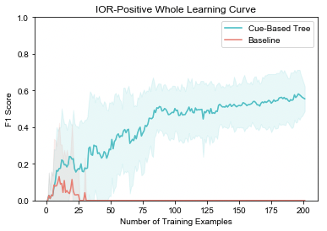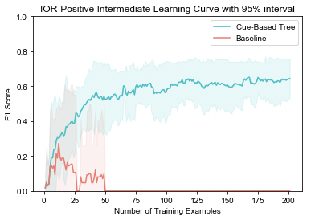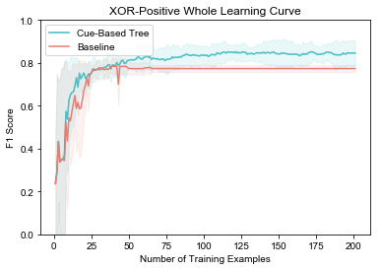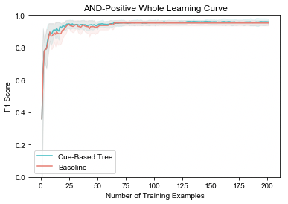Figure 6: A Decision Tree Can Distinguish XOR, IOR, and AND using intonation, consistency, speech act, and utterance type

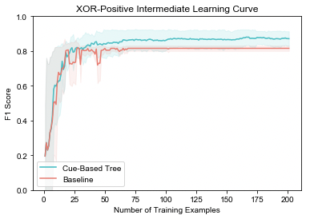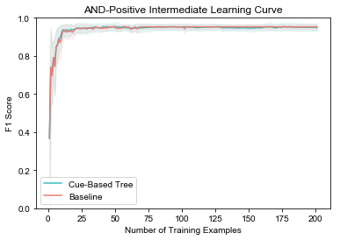

Caption: When trained on data containing examples with AND, XOR, and IOR interpretations, the decision tree (gini = 0.01) average F1 scores for classes AND (A), XOR (B), and IOR (C) as a function of the number of training examples in the baseline and cue-based models. When trained on data containing all examples, the decision tree (gini = 0.01) average F1 scores for classes AND (D), XOR (E), IOR (F), NOR (G), and NPQ (H).

Comment: Since the readers already know what the trees look like, I would advocate moving the trees to the supplementary figures

